

Written by: | Bastian L | Date: 20-juin-11
Reviewed by: | Charre P | Date: 20-juin-11
 |  | Date:
Authorized by: |  | Date: 20-juin-11

AUDIENCE
CURRENT DOCUMENT RELEASE
V0.1 | 20-juin-11

Validation Documentation
EXTENSIBILITY OF MIND IDE
Evolution history

Release | Date | Evolutions description
V0.1 | 20-Jun-11 | Document initialization

Summary
1. Introduction 4
2. Open Source Code 5
2.1 Create à new constraint: 5
2.2 Modify a constraint 9
2.2.1 Remove a target 9
2.2.2 Add a new target 10

Introduction

Mind Ed is a part of an open-source project. Easiness of using of the software and enhancing the functionalities took an important part in the development thinking of the software. The validation extension points that are available in the application allows the software to be scalable allowing users to add or modify constraint in diagrams.

Currently, in Open Source Code, we have a constraint on Component or Interface name. This constraint prevent user to set component name with a empty name. If this constraint is modified, we can force the user to write a name with a minimum number of characters.
This document explains how to add new constraints or how to modify existing constraints.

Open Source Code

The Plug-in org.ow2.mindEd.adl.validation implements the default MinEd Constraints. We can add, remove or modify some constraints.

Create a new constraint:
Open plugin.xml in org.ow2.mindEd.adl.validation project and select “Extensions” tab. Open “org.eclipse.emf.validation.constraintProviders” extension then ”constraintProvider” and “constraints”. The constraints “MindEdNameConstraints” and “MindEdBindingConstraints” are defaults constraints for MindEd. We can modify or remove them.
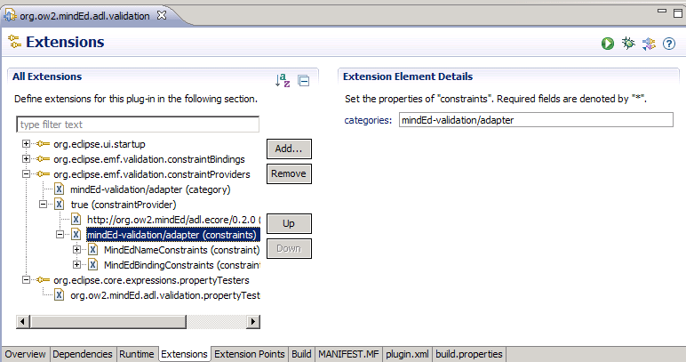

Add a new constraint with a right click on “minded-validation/adapter (constraints)”>>New>>constraint.
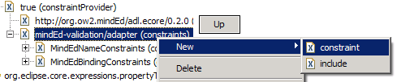
Fill the different entries. For this example, we create a new TutoConstraint. This constraint aims on the TutoConstraintClass which will be created next.
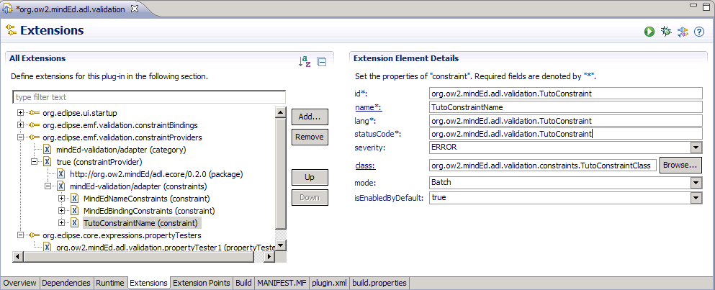

Create a new class in “or.ow2.mindEd.adl.validation.constraints” package in “or.ow2.mindEd.adl.validation” project:
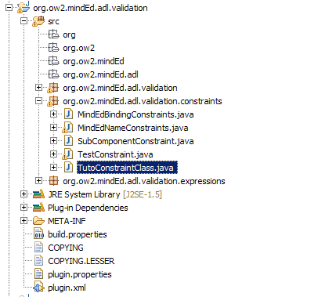
And extend this class with “AbstractModelConstraint” class. In this class, you can make your own constraint. Now in the pulgin.xml file, you must select your target for this constraint.
Make a right click on TutoConstraintName in plugin.xml and select New>>target:
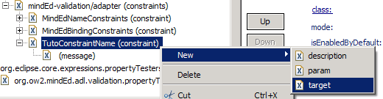
This target is a class from ECORE model. Choose “CompositeComponentDefinition” for example. When you validate the diagram, TutoConstraintClass will be called if the component opend in the diagram is a Composite Component. You can define more than one target and check in “TutoConstraintClass” on which target the validation is called.
In your “TutoConstraintClass”, add this code:
public class TutoConstraintClass extends AbstractModelConstraint{

@Override
public IStatus validate(IValidationContext ctx) {

// Check if validation come from the define class
if(ctx.getTarget().eClass().getClassifierID()==AdlPackage.COMPOSITE_COMPONENT_DEFINITION)
{
// Convert context Target in model class
CompositeComponentDefinition compositeComponent = (CompositeComponentDefinition) ctx.getTarget();
//
// Insert your test code
//
}
return ctx.createSuccessStatus();
}
}

Your constraints are executed when you try to validate the model. Currently, this constraint is defined in BATCH mode. You must make a manual validation. In a MindEd diagram, click on Edit > Validate. This operation checks your constraint.
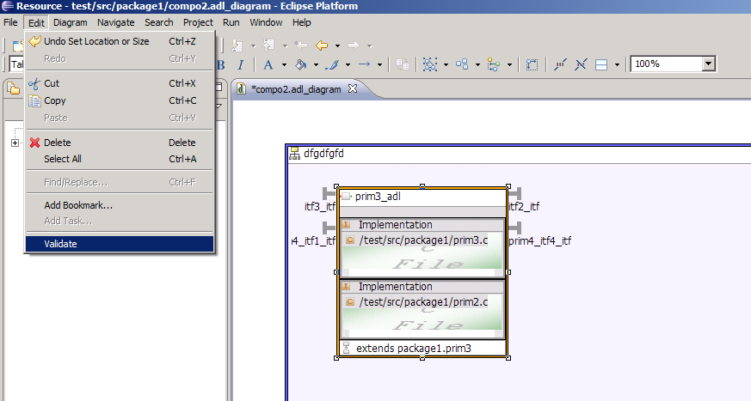

If you want the constraint to be tested automatically, you must set the constraint in live mode. Find your constraint in plugin.xml file and set mode in Live:
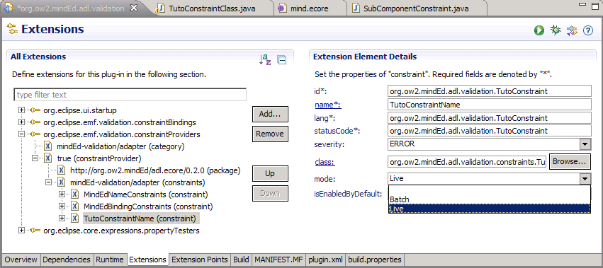

Modify a constraint

Remove a target
In the plugin.xml file, in org.ow2.mindEd.adl.validation project, with a right click on the target, we can delete this target.
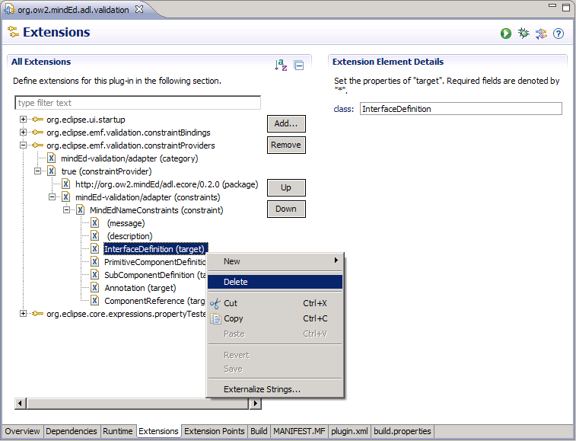
Check the constraint class code if there are no constraint on target type, but normally, class code is not called when you work on the deleted target.

Add a new target
Make a right click on your constraint in plugin.xml and select New>>target:
In constraint class code, add test on type of target and add your own constraint code on this target.

